

Packet Tracer - Propagate a Default Route in OSPFv2

Name: Luis Enrique Pérez Señalin

# Addressing Table

|  |  |  |  |  |
| --- | --- | --- | --- | --- |
| **Device** | **Interface** | **IPv4 Address** | **Subnet Mask** | **Default Gateway** |
| R1 | G0/0 | 172.16.1.1 | 255.255.255.0 | N/A |
|  | S0/0/0 | 172.16.3.1 | 255.255.255.252 |  |
|  | S0/0/1 | 192.168.10.5 | 255.255.255.252 |  |
| R2 | G0/0 | 172.16.2.1 | 255.255.255.0 | N/A |
|  | S0/0/0 | 172.16.3.2 | 255.255.255.252 |  |
|  | S0/0/1 | 192.168.10.9 | 255.255.255.252 |  |
|  | S0/1/0 | 209.165.200.225 | 255.255.255.224 |  |
| R3 | G0/0 | 192.168.1.1 | 255.255.255.0 | N/A |
|  | S0/0/0 | 192.168.10.6 | 255.255.255.252 |  |
|  | S0/0/1 | 192.168.10.10 | 255.255.255.252 |  |
| PC1 | NIC | 172.16.1.2 | 255.255.255.0 | 172.16.1.1 |
| PC2 | NIC | 172.16.2.2 | 255.255.255.0 | 172.16.2.1 |
| PC3 | NIC | 192.168.1.2 | 255.255.255.0 | 192.168.1.1 |
| Web Server | NIC | 64.100.1.2 | 255.255.255.0 | 64.100.1.1 |

**Objectives**

**Part 1: Propagate a Default Route Part 2: Verify Connectivity**

# Background

In this activity, you will configure an IPv4 default route to the Internet and propagate that default route to other OSPF routers. You will then verify the default route is in downstream routing tables and that hosts can now access a web server on the Internet.

# Instructions

**Part 1: Propagate a Default Route**

## Step 1: Test connectivity to the Web Server

1. From PC1, PC2, and PC3, attempt to ping the Web Server IP address, 64.100.1.2. Were any of the pings successful?

**Packet Tracer - Propagate a Default Route in OSPFv2**

**R:** The ping failed on each pcs.

What message did you receive, and which device issued the message?

**R:** On some pcs we have the Request time out in some petition of the 4 of each ping but letter of two “request time out error” we had the Reply from 172.16.2.1: Destination host unreachable.

1. Examine the routing tables on routers R1, R2, and R3.

What statement is present in the routing tables that indicates that the pings to the Web Server will fail?

**R:** The configuration of the routing tables allow to communicate with the others networks but the message on each route “Gateway of last resort is not set” is the problem that causes the failure.

## Step 2: Configure a default route on R2.

Configure **R2** with a directly attached default route to the Internet.

R2(config)# **ip route 0.0.0.0 0.0.0.0 Serial0/1/0**

**Note**: Router will give a warning that if this interface is not a point-to-point connection, it may impact performance. You can ignore this warning because it is a point-to-point connection.

## Step 3: Propagate the route in OSPF.

Configure OSPF to propagate the default route in OSPF routing updates.

R2(config)# **router ospf 1**

R2(config-router)# **default-information originate**

## Step 4: Examine the routing tables on R1 and R3.

Examine the routing tables of **R1** and **R3** to verify that the route has been propagated.

R1> **show ip route**

<output omitted>

Gateway of last resort is 172.16.3.2 to network 0.0.0.0

<output omitted>

O*E2 0.0.0.0/0 [110/1] via 172.16.3.2, 00:00:08, Serial0/0/0

!

R3> **show ip route**

<output omitted>

Gateway of last resort is 192.168.10.9 to network 0.0.0.0

<output omitted>O*E2 0.0.0.0/0 [110/1] via 192.168.10.9, 00:08:15, Serial0/0/1

# Part 2: Verify Connectivity

Verify that **PC1**, **PC2**, and **PC3** can ping the web server.

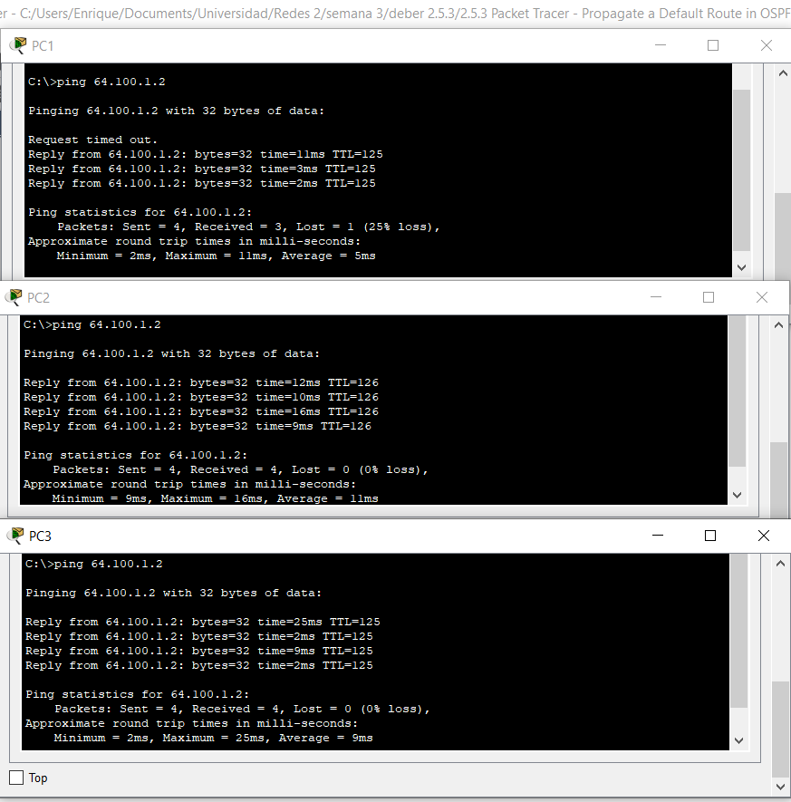

**ScreenShoot of activity:**